**ASSIGNMENT 2: FINAL ESSAY**

(Links at the end)

**Introduction**

The concept of this project is a Fashion Time Machine, an interactive experience that visualises and gamifies women’s fashion history through UI design and digital storytelling. Fashion throughout the decades is practically a cultural record of that era. “Studying fashion media from a historical perspective is also studying women’s history” (Castaldo Lundén, 2020). The project is composed of three parts, six digitally manipulated images, three high fidelity user interface prototypes and lastly, a GIF animation.

Its aim is to explore how visual design and interaction can be used to archive and engage with women’s fashion history in a playful yet accessible format.

This project uses the 1920s and 1960s as case studies to contrast interactive and static design approaches. This choice was made in response to time constraints and the complex and experimental nature of the theme.

A variety of tools and technologies were used across this project, combining familiar techniques with newly learned ones. [Procreate](https://procreate.com/) was used for illustration, [Affinity suite](https://affinity.serif.com/en-gb/?srsltid=AfmBOorUyIJj0E4Y8VlKVmoVMVtbTlUzRrbxsjyhOEm4-KjUltgfkmgN) for composing and editing images and finally, [Figma](https://www.figma.com/) for creating high-fidelity interactive UI that brings the project to life.

This essay discusses the design rationale, visual language, technical execution and iterative process behind each part of the project, including research insights, creative strategies and areas identified for future development.

**USER INTERFACE DESIGNS**

**Concept development and design approach**

The most important aspect of the Fashion Time Machine is the UI design, as this paves the way for how the user interacts with and experiences fashion history. Whilst there are plenty of static fashion archives ([Vogue Archive](https://archive.vogue.com/), [Victoria and Albert Museum](https://collections.vam.ac.uk/search/?id_category=THES48957&page=1&page_size=15) etc.), this interface aims to immerse the user in the visual and emotional identity of each decade.

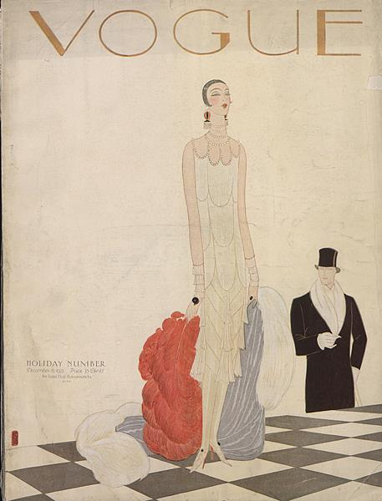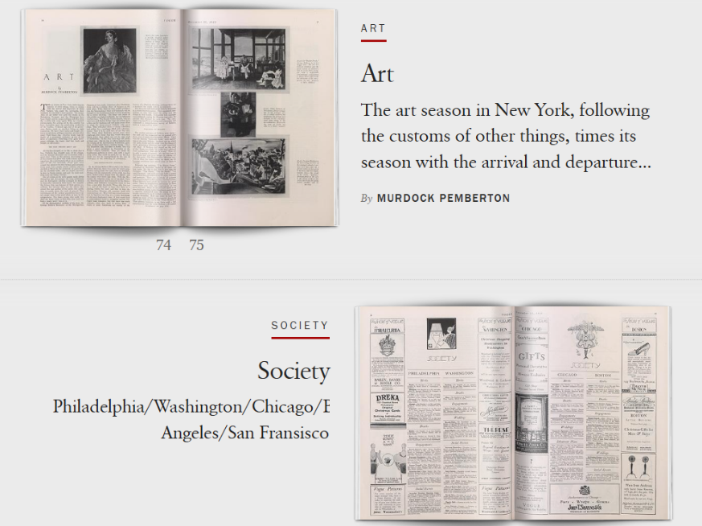

*Image 1 & 2. Vogue Archive, December 15, 1925 issue (from website)*

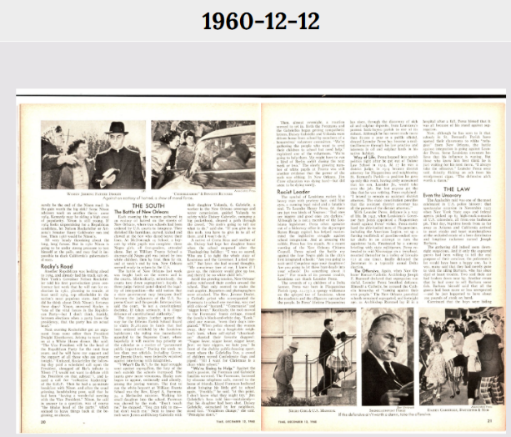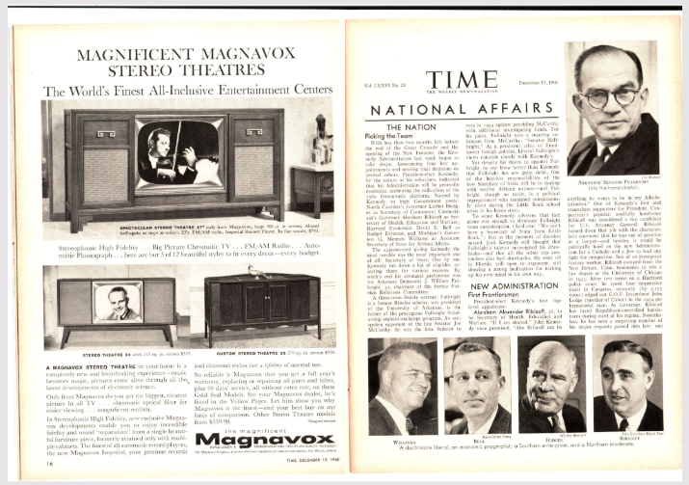

*Image 3 & 4. The Vault, Time magazine, December 12, 1960 (from website)*

After thorough research, design choices were tailored to reflect historical aesthetics (The Vault, 1923; Vogue Archive, 1925). Music from the specific era was also utilised to further immerse the designer in the specific decades and help with the design process.

The gamification of this concept of a fashion archive was inspired by retro childhood games. These games now bring a sense of melancholy and provide a look into that decade’s technological advancements and cultural aspects, which go perfectly with the concept of a time machine.

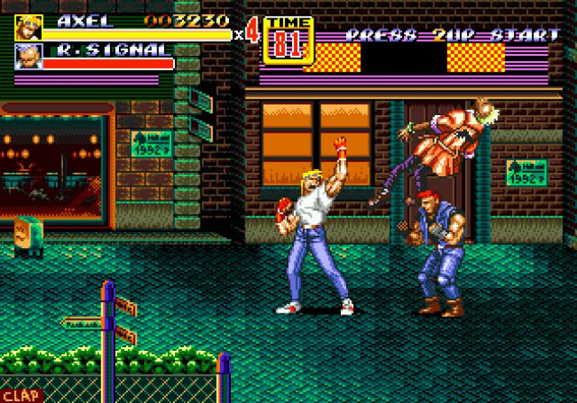

*Image 5. Sega Genesis game called Streets of Rage (from Google)*

The goal was to mix aspects of the retro games look with modern interactivity. Norman (2013) highlighted that a “good design is actually a lot harder to notice than poor design, in part because good designs fit our needs so well that the design is invisible”. Following this principle, a decision was made to keep the navigation intuitive and minimalistic, whilst letting the visuals take centre stage.

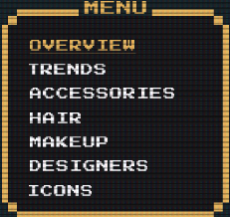 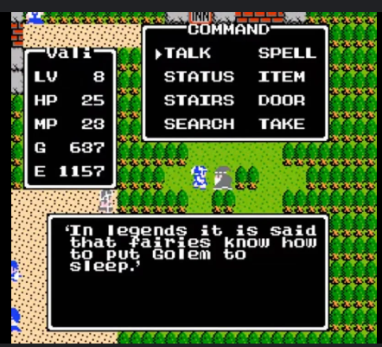

*Image 6 & 7. Screenshot of nav menu (from Figma) and inspiration (from Google)*

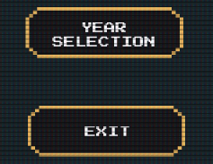 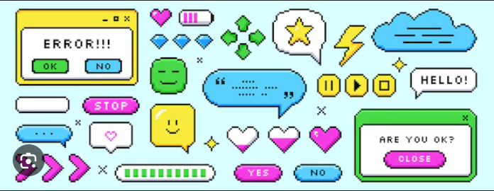

*Image 8 & 9. Screenshot of nav buttons (from Figma) and inspiration (from Google)*

This way of displaying navigation is minimalistic, whilst also on par with the retro style. A simple menu was one of the highlights of retro games. The design of the box was created in Affinity Photo by hand.

**Visual aspects – Layout, colour, typography, accessibility and content**

**Layout**

The layout strategy was built around progressive disclosure (Nielsen, 2006), revealing more information and interactivity as the user navigates through time. The starting screen/homepage introduces the user to the retro game and time travel concepts, which then lead to the individual decade screens.

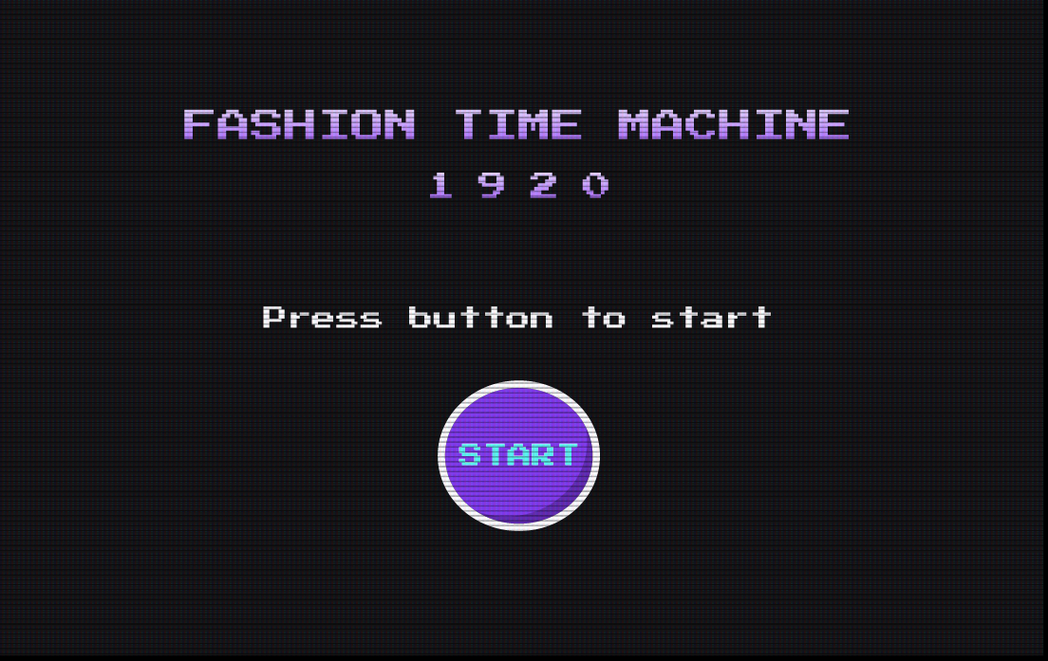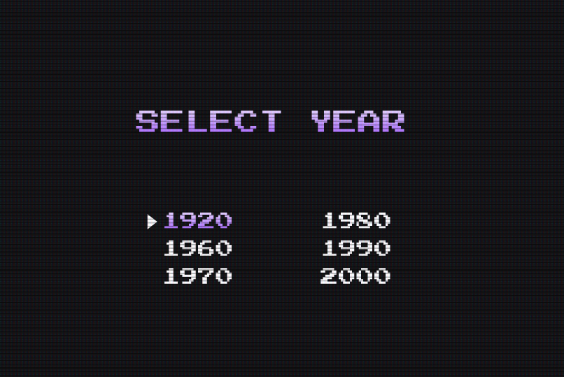

*Image 10 & 11. Screenshots of homepage and timeline screens taken (from Figma)*

The images above mimic the feel of the starter screen of an old Nintendo game, along with player selection screen (see below).

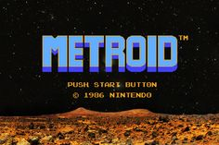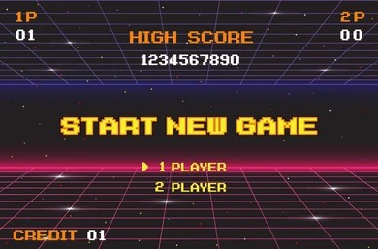

*Image 12 & 13. Images from retro console games (from Google)*

Research into 1920s and 1960s show that a grid layout was often preferred in print publications, more specifically three-column grid layout (*see Image 1, 2, 3 & 4*) (Ambrose and Harris, 2021). Due to the envisioned design and way of displaying the content, a mix of one and two-column grid layout was instead adopted for this project, whilst still maintaining the feel of the old times. This is also consistent with best practices from design systems like those in Figma or Google’s Material Design. A layout that’s well-structured improves readability.

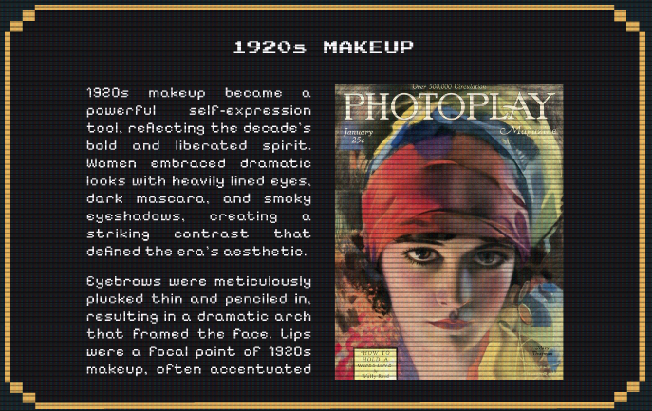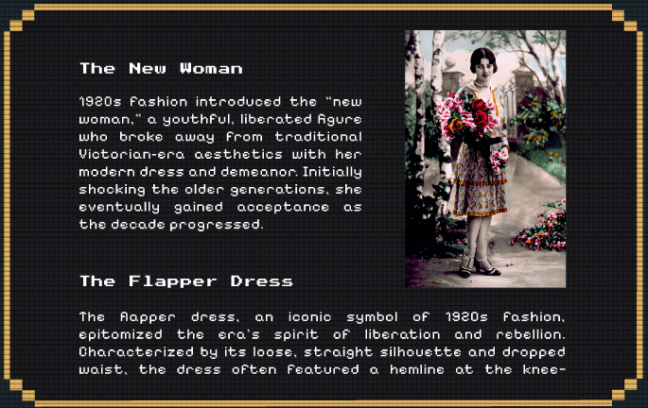

*Image 14 & 15. Screenshots of interactive content boxes (from Figma)*

Whilst the old publications have a very convoluted feel due to the three-column grid layout, the old videogames allowed for ample spacing in their UI, a characteristic which this project is utilising.

To further immerse the user in the feel of a time machine and create a sense of discovery and fun, a transition screen was also added with a vortex animation GIF. As this would be an accessibility issue for users prone to seizures or photosensitivity, a warning was added. This warning prompts the user with two options, one to view the animation or to skip, therefore ensuring best design practices (Garrett, 2010).

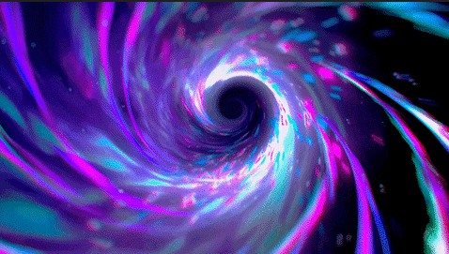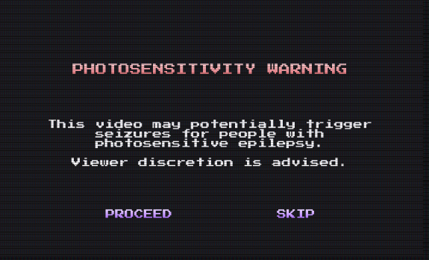

*Image 16 & 17. Screenshot of vortex and the warning pop-up (from Figma)*

To emulate the feel of a retro game, a CRT overlay was added on top of the screens to mimic the look of old console games.

The main idea was to immerse and excite the user through gamification. Interactive components such as hover states and varied transitions between pages and popups were designed in Figma using various animations to further immerse the user in the experience.

**Colour Palettes**

Both decades were designed around a historically inspired visual themes. For instance, the 1920s UI is inspired by the Art Deco movement (Dewidar, 2017), with geometrical borders, black, gold and jade tones (Mervis, 2022).

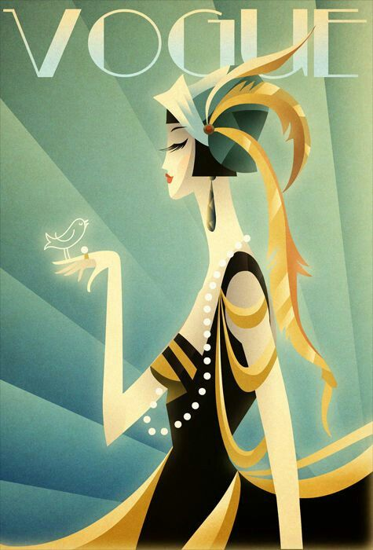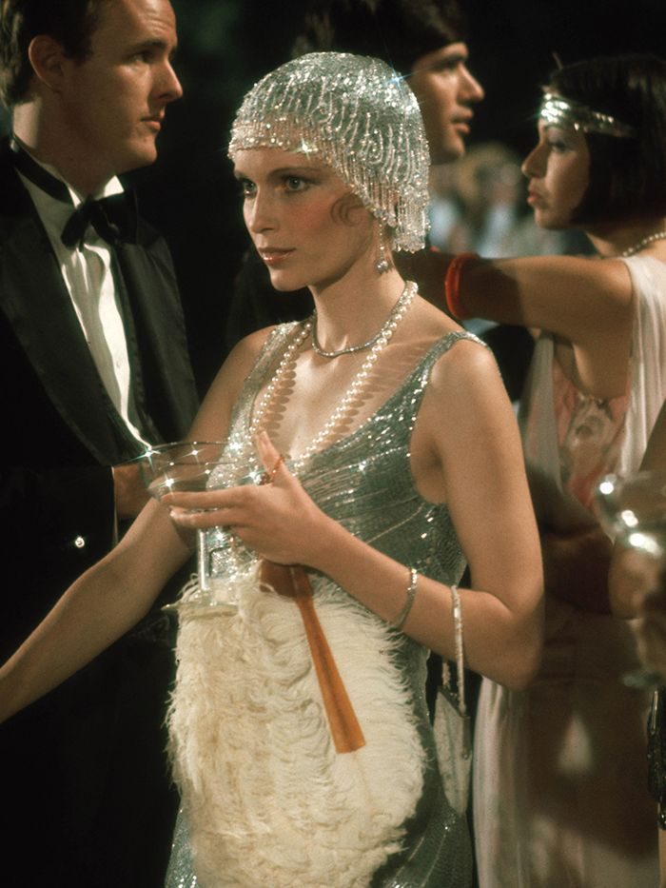

*Image 19 & 20. Fashion looks from the 20s (from Google)*

Whilst the Gatsby and glitz vibe wit well with the 1920s look (Glennon, 2016), to blend it with the retro game idea, the visuals were simplified, whilst still maintaining and mimicking the 20s feel.

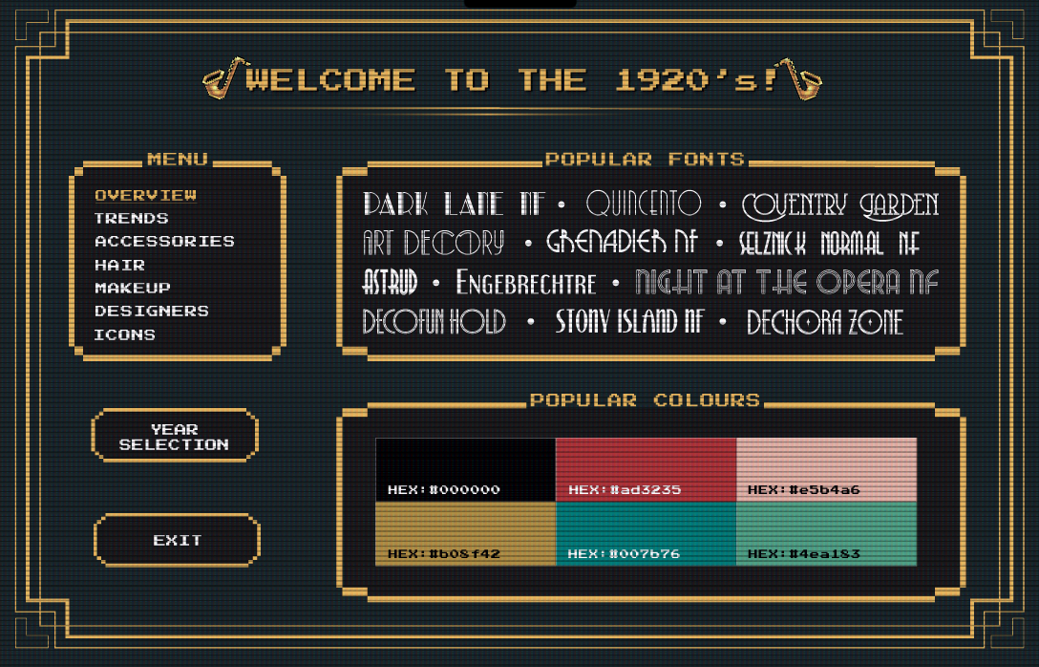

*Image 19. Screenshot of interactive Overview of 1920s page (from Figma)*

In contrast, the 1960s design uses psychedelic colours, more fluid and rounded shapes inspired by vintage poster art and fashion advertisements of the time.

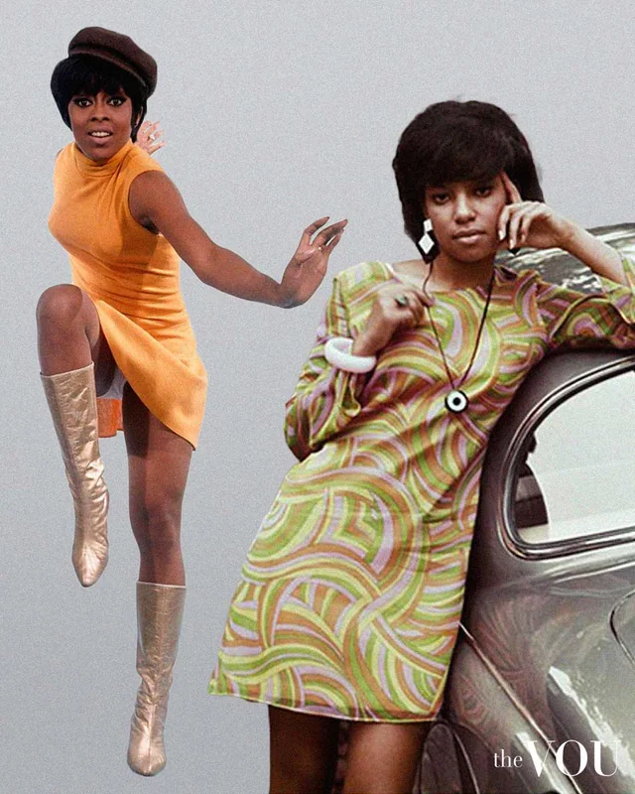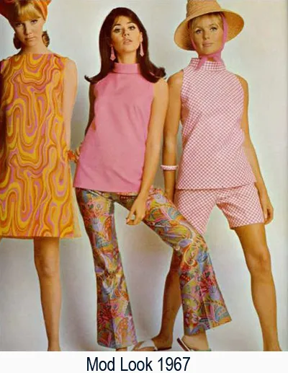

*Image 20 & 21. Fashion looks from the 60s (from Google)*

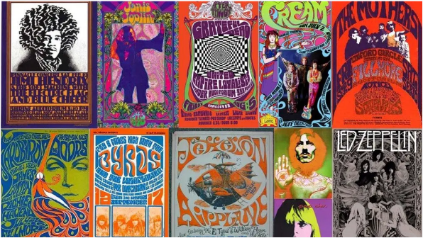

*Image 22. Collection of 60s posters (from* [*goodness exchange*](https://goodness-exchange.com/the-psychedelic-posters-that-define-a-generation/)*)*

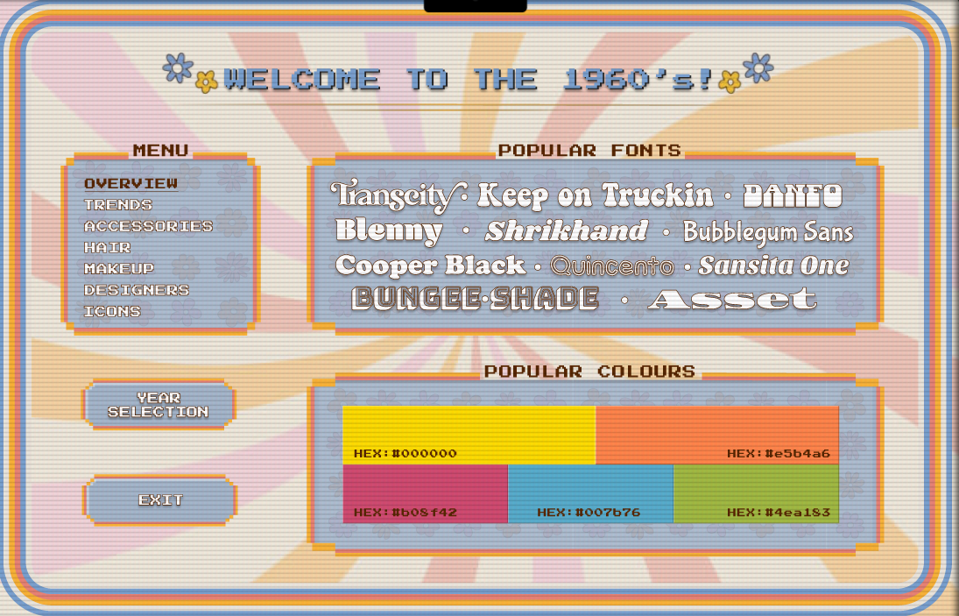

*Image 23. Screenshot of static Overview of 1960s page (from Figma)*

Colour contrast checkers ([WebAIM](https://birkbeckuol-my.sharepoint.com/personal/abreah01_student_bbk_ac_uk/Documents/Typography is more than legibility)) were also used when choosing background colours, border colours and font colours, to further ensure good design practices (Sherin, 2013) as according to WCAG 2.2 (W3C, 2024). Whilst some colour combinations failed (see below), a way to make it more readable was to add a stroke of a much darker colour and a drop shadow. This added contrast and made the text more readable.

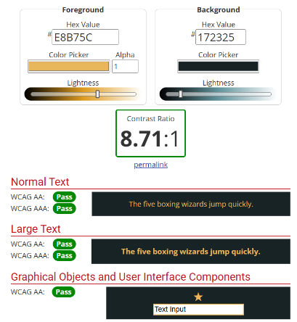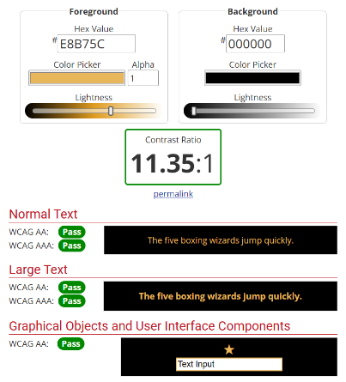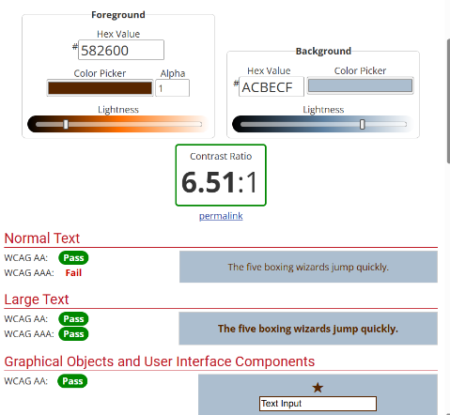

*Image 24, 25 & 26. Results from contrast checker for both designs (from WebAIM)*

**Typography**

One of the early designs used a variety of fonts to further immerse the user in that era. However, as the project evolves, and more UIs of the decades are added, the variety and mix of fonts could easily overwhelm the user. Using one consistent font across all screens was a conscious design decision made to maintain brand unity and readability (Figma, 2023), even with the UI design shifting through the decades. As Garfield (2011) highlights, typography is more about tone and consistency, rather than legibility. The designs use Google’s font Press Start 2P font: capitalised for headers and navigations, title case for subheaders. As for body text, Pixelify Sans was used instead as it provided a better readability with letters and spacing making the text clearer and more breathable (Elam, 2007).

Instead of using different typography throughout the UI, a section based on decade inspired fonts was added to the overview page of both decades. This section contains fonts that either look like that decade’s fonts or are inspired by the overall look and theme of the decade.

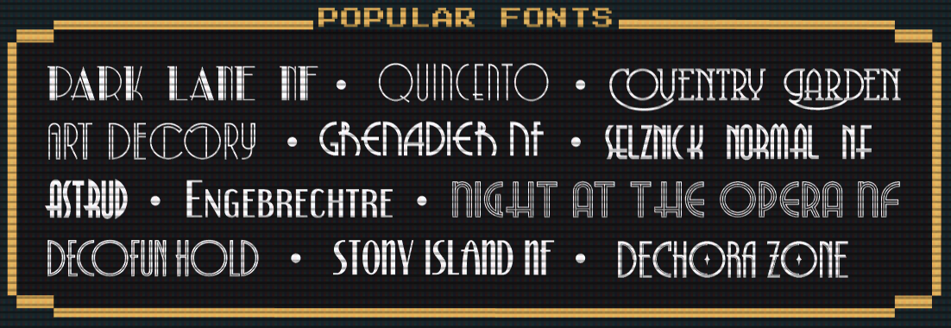

*Image 27. Screenshot of 1920s inspired fonts (from Figma)*

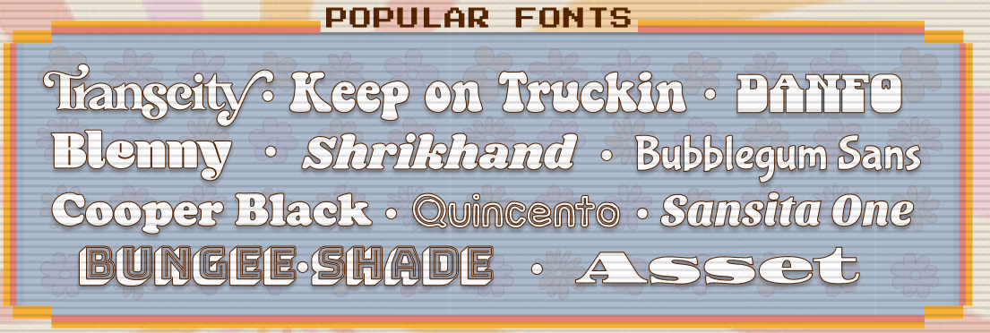

*Image 28. Screenshot of 1960s inspired fonts (from Figma)*

**Content**

The content and imagery displayed in the black box was sourced from various websites. Please see references for full list.

**DIGITALLY MANIPULATED IMAGES**

The manipulated images played an important role in defining the tone and identity of each decade featured in this project. Whilst the initial idea was to design one poster per decade, a decision was made to instead experience with different image manipulation techniques to explore different looks. The images were created using Procreate for hand-drawn illustrations and Affinity Photo and Designer for image composition, editing and vector work. The typography found throughout the posters was manually edited, with purposeful capitalisation, kerning, tracking and snear, to recreate certain looks.

The below image was inspired by old fashion magazine covers from the 20s. It mimics a vintage magazine using structured layout, muted tones and period style photography, or illustration in this case.

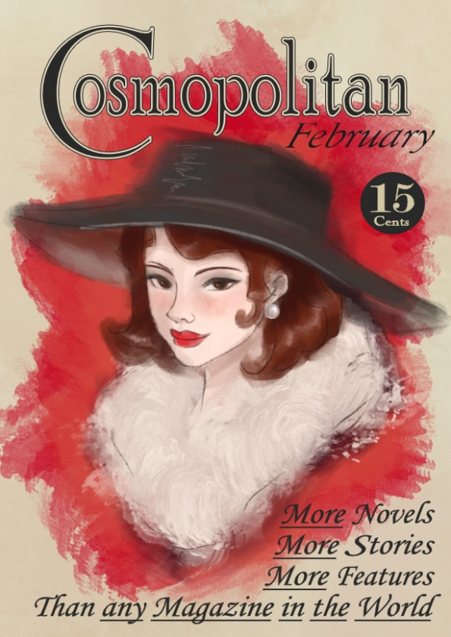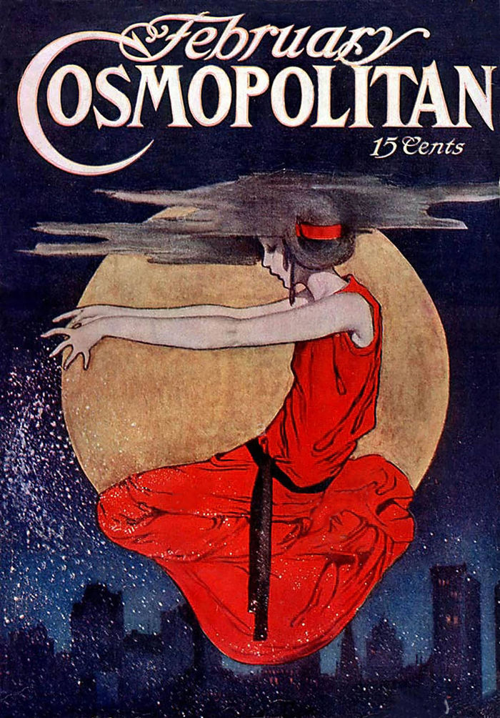

*Image 29 & 30. Magazine cover design (left) inspired by 20s magazine (right)*

Fonts used: Perpetua Titling MT, Poor Richard, Monotype Corsiva, Nicholas Cochin, Modern No.20

Techniques used: digital painting, HSL shift adjustment, recolour adjustment, mesh warp, curves adjustment, typography and character manipulation

The following poster is inspired by the 60’s instead. The 1960s visuals were a mix of psychedelic aesthetics with bold colours and eccentric elegance. However, fashion magazines had a more poised look. A mix of both aesthetics with pale and loud colours contrasting each other was chosen.

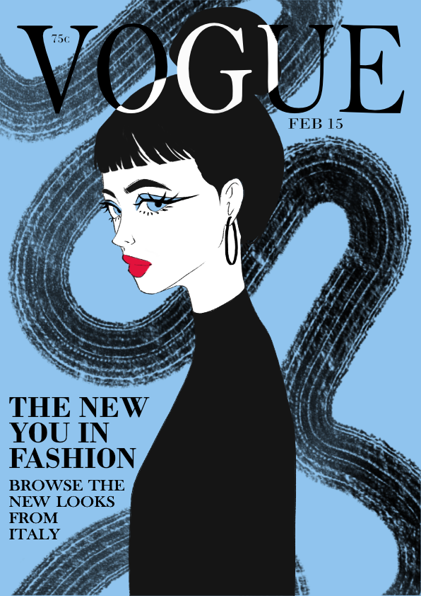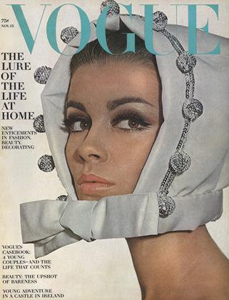

*Image 31 & 32. Magazine cover design (left) inspired by 60s magazine (right)*

Fonts used: Bodoni MT, Baskerville Old Face, Bell MT

Techniques used: digital painting, typography and character manipulation

The last poster within the decades theme, a party poster inspired by the Great Gatsby. Art Deco was a big inspiration for this piece, mixing black and gold, geometrical shapes and borders with fonts that resembled the roaring 20s. The poster was fully illustrated in Affinity Designer and Photo, with all elements being designed by hand.

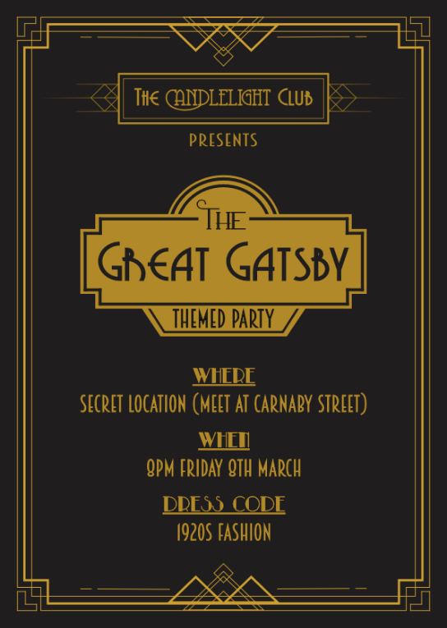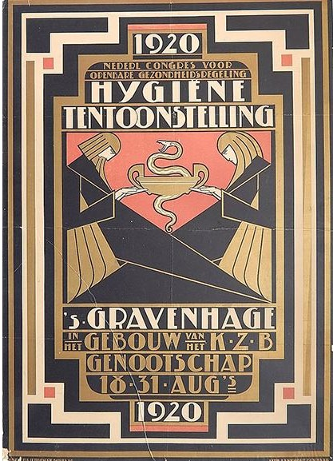

*Image 33 & 34. Great Gatsby poster (left), and inspiration (right)*

Fonts used: Arkadelphia, Breamcatcher, Coventry Garden, Grenadier NF, Park Lane NF

Techniques used: vector design, FX, typography and character manipulation

The following image was created with inspiration from EDM concerts, specifically Untold Festival. The EDM festivals are generally loud and full of bright neon colours, which is what was attempted to recreate with this poster. 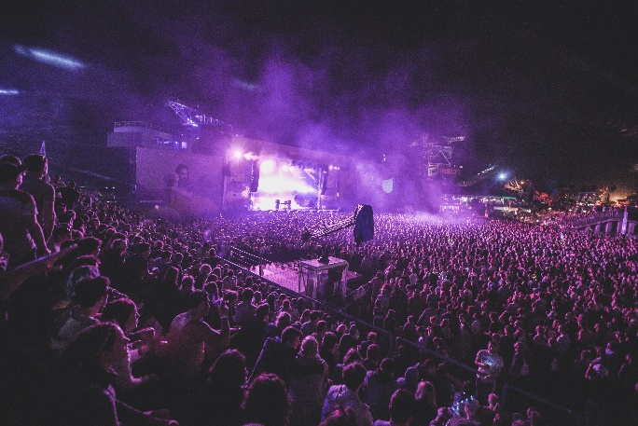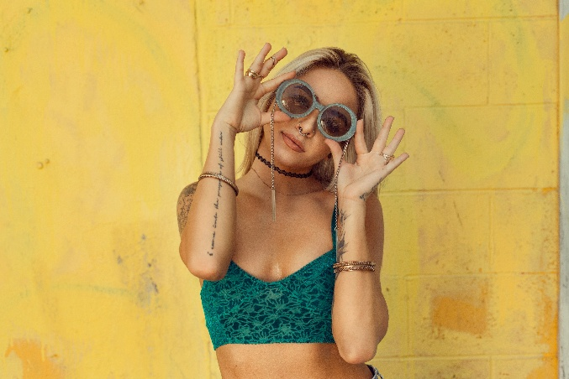

*Image 35 & 36. Original images used to make the poster*

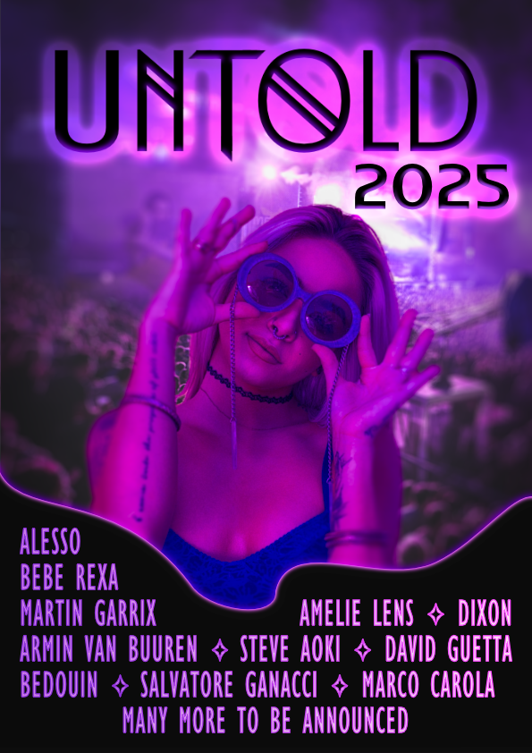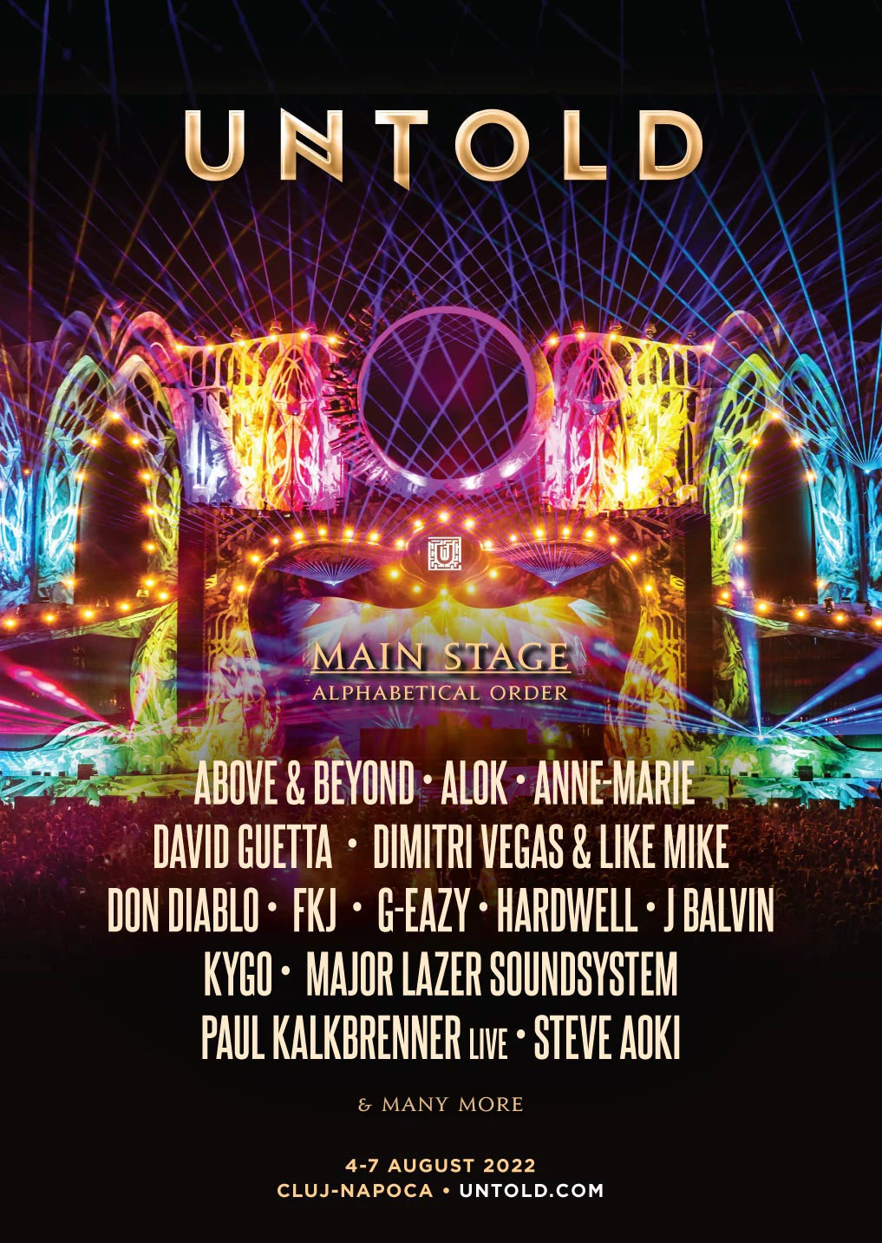

*Image 37 & 38. Untold inspired poster (left) and actual Untold poster (right)*

Fonts used: Crostan, World of Water, Gill Sans MT Condensed

Techniques used: combining multiple images, selection and cropping, FX, masks, vector design, gradient map adjustments, depth of field blur, curves adjustments, colour balance adjustments, vignette, typography and character manipulation

The last two images are an exploration of collage graphics, morphing techniques and colour correction. The first is taking inspiration from the world of CyberPunk (videogame), whilst the second is exploring photo-realistic image manipulation.

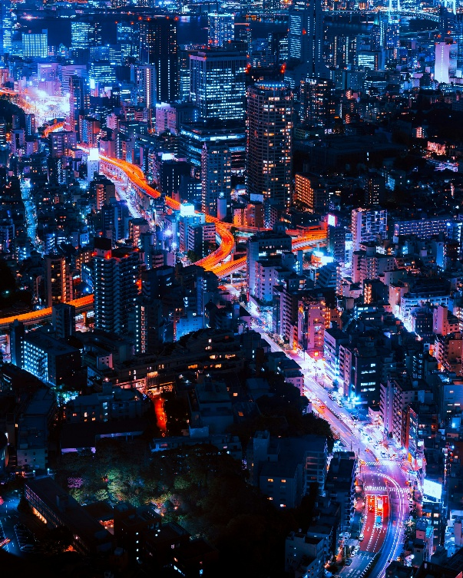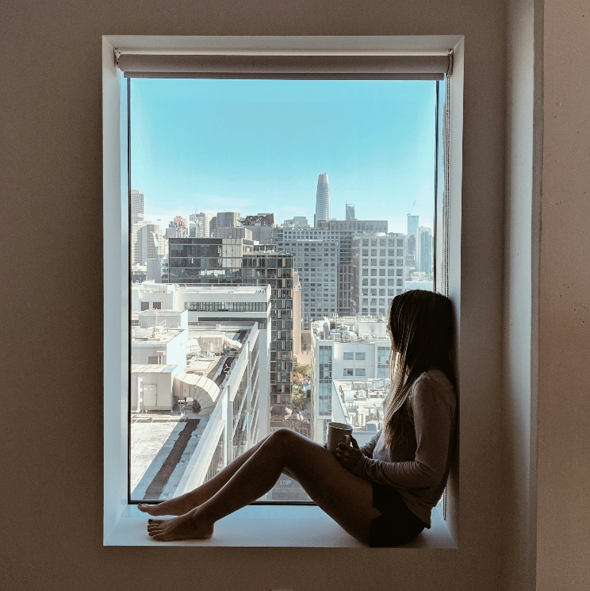

*Image 39 & 40. Original images used to create the girl-in-the-window poster*

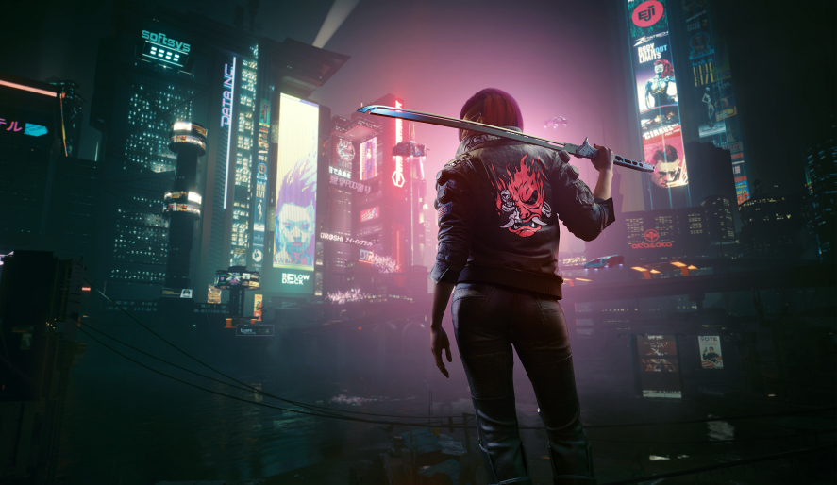

*Image 41. Picture from the game CyberPunk used for inspiration*

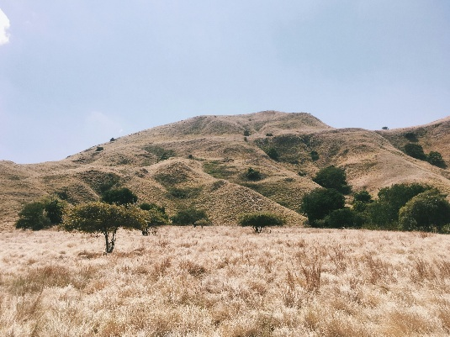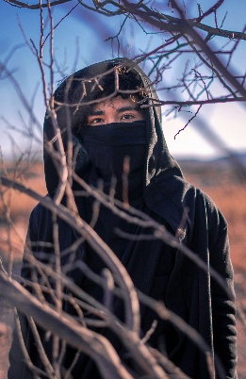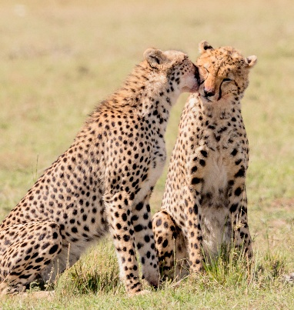

*Image 42, 43 & 44. Images used for the collage*

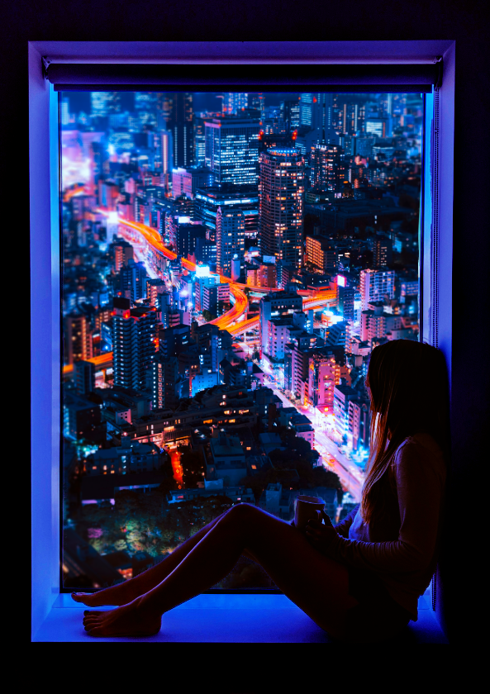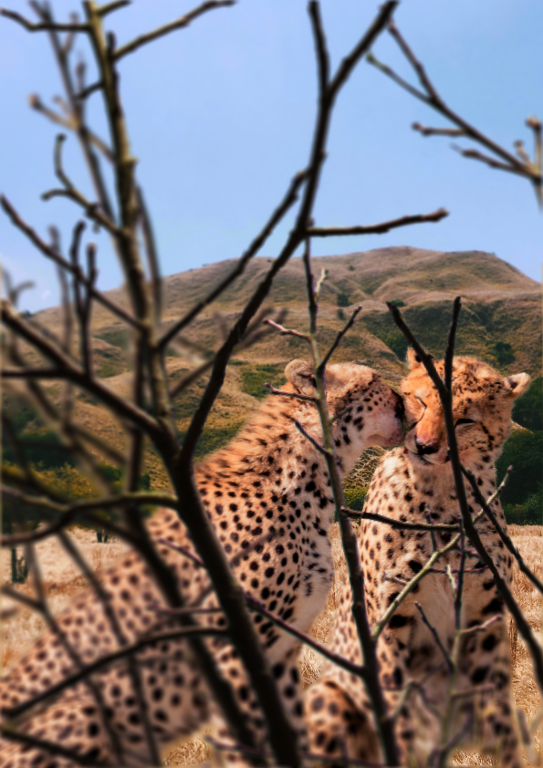

*Image 45 & 46. CyberPunk inspired poster (left) and photo collage (right)*

Techniques used: combining multiple images, selection and cropping, masks, curves adjustments, vibrance adjustments, depth of field blur

**THE GIF**

To reflect the theme of time travel, a looping banner GIF was created using Affinity Photo, styled to match the homepage of the Fashion Time Machine prototype.



*Image 47. GIF representing time travel*

Stylised text was exported from Figma as PNGs, layered and edited. A glitch effect was applied to each frame using Glitch Generator (see references), then compiled in GIMP into a single GIF that visually represents jumping through different eras.

**CONCLUSION**

The Fashion Time Machine project explored how interactivity and stylised design can make historical content more fun and engaging. Through a combination of gamified UI, strong visual identity and era-specific digital imagery, the prototype invites users to experience fashion history in a more immersive and creative way. Attention to accessibility, consistency and interaction design ensured the experience was not only visually appealing but also user-friendly.

Further development of the project by adding more UIs, maybe more variation in design layout and extra interactivity is necessary to fully provide the time travel experience.

**Link to website:** <https://birkbeck2.github.io/canary-visual-design-manipulated-images-AnaBrh/index.html>

**Link to Figma file:** <https://www.figma.com/design/lbojwoVreEshSNxwj8QkXc/Fashion-time-machine?m=auto&t=FjaoPDtODPHSh4iU-6>

**Link to Figma Prototype:** <https://www.figma.com/proto/lbojwoVreEshSNxwj8QkXc/Fashion-time-machine?page-id=20%3A2&node-id=141-4115&viewport=521%2C307%2C0.11&t=rbTZNKAw90ED2ZJ7-1&scaling=scale-down&content-scaling=fixed&starting-point-node-id=21%3A4>

**REFERENCES AND RESOURCES**

**Academic references**

Ambrose, G. and Harris, P. (2021). Grids for Graphic Designers. Bloomsbury Publishing.

Castaldo Lundén, E. (2020) ‘Exploring Fashion as Communication: The Search for a new fashion history against the grain’, *Popular Communication*.

Dewidar, K.M. (2017). Art déco Style (1920-1940). Professor of Architecture, Ain Shams University of Cairo, Egypt.

Elam, K. (2007). Typographic Systems of Design: Frameworks for Type Beyond the Grid (Graphic Design Book on Typography Layouts and Fundamentals). Princeton Architectural Press.

Figma. (2023). Typography in Design. Available at: <https://www.figma.com/resource-library/typography-in-design/>

Garrett, J.J. (2010). The Elements of User Experience: User-Centered Design for the Web and Beyond. Berkeley, CA: New Riders.

Garfield, S. (2011). Just my type – a book about fonts. Profile Books. London, UK.

Glennon, J. (2016). Art Deco Movement Overview and Analysis. The Art Story. Available at: <https://www.theartstory.org/movement/art-deco/>

Mervis, M. (2022). Popular Color Palettes Through the Decades: 1920s-1960s. Available at: <https://www.dunnedwards.com/pros/blog/popular-color-palettes-through-the-decades-1920s-1960s/>

Nielsen, J. (2006). Progressive disclosure. Available at: <https://www.nngroup.com/articles/progressive-disclosure/>

Norman Donald, A. (2013). *The design of everyday things*. MIT Press.

Sherin, A. (2013). Design Elements, Color Fundamentals. Beverly, MA: Rockport Publishers.

W3C. (2024). Web Content Accessibility Guidelines (WCAG) 2.2. In W3C Recommendation. Available at: <https://www.w3.org/TR/WCAG22/>

**Fashion articles**

<https://www.vogue.co.uk/article/1920s-fashion-trends>

<https://fashionhistory.fitnyc.edu/1920-1929/>

<https://fashionhistory.fitnyc.edu/1960-1969/>

<https://www.fashiongonerogue.com/1920s-fashion-women-trends/>

<https://www.fashiongonerogue.com/60s-fashion-trends/>

<https://study.com/academy/lesson/1920s-fashion-history-trends.html>

**Resources**

Glitch Generator - <https://glitchgenerator.com/>

Vogue Archive - <https://archive.vogue.com/>

Victoria and Albert Archive - <https://collections.vam.ac.uk/search/?id_category=THES48957&page=1&page_size=15>

CRT Overlay - <https://mega.nz/folder/zV1QhaoQ#pXkEU4lItuKYAzN9_UX29w>

Goodness Exchange - <https://goodness-exchange.com/the-psychedelic-posters-that-define-a-generation/>

Vogue 1925 Issue - <https://archive.vogue.com/issue/19251215>

Time 1923 Issue - <https://web.archive.org/web/20230203185103/https:/time.com/vault/year/1923/>